For an **undirected graph**, 2 x number of edges = sum of degree of all vertices.

Path is defined as a sequence of nodes such that none of the node repeats.

**Storing a Graph**

1) Adjacency Matrix: For an undirected graph with 1 based indexing, making a matrix of n+1 x n+1 dimension and fill it as per the edges.

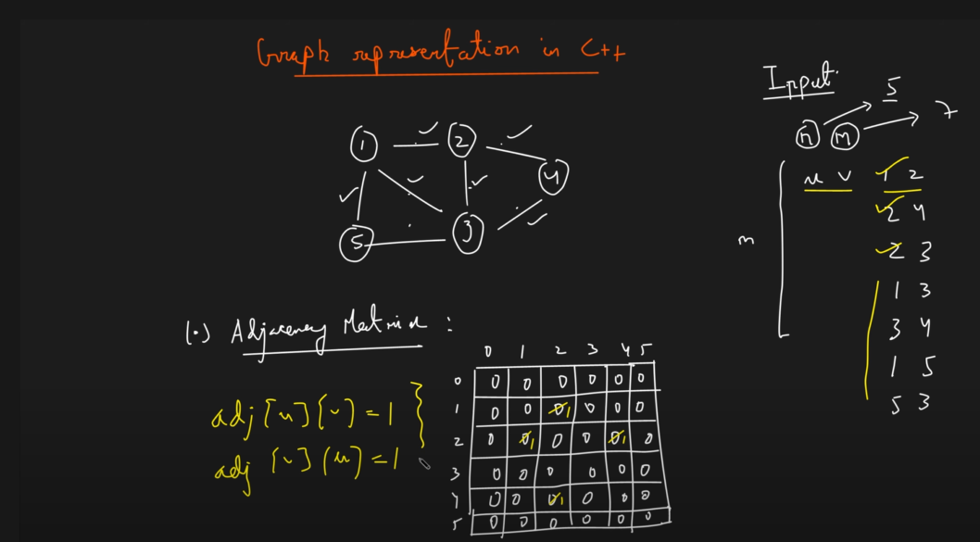

Disadvantage is that if a large number like 10^5 is given, we cant draw a matrix of this size.

Hence, we use Adjacency List (because Adjacency Matrix was using a space complexity of nxn).

2) Adjacency List: Again for 1 based indexing we take the size as n+1.

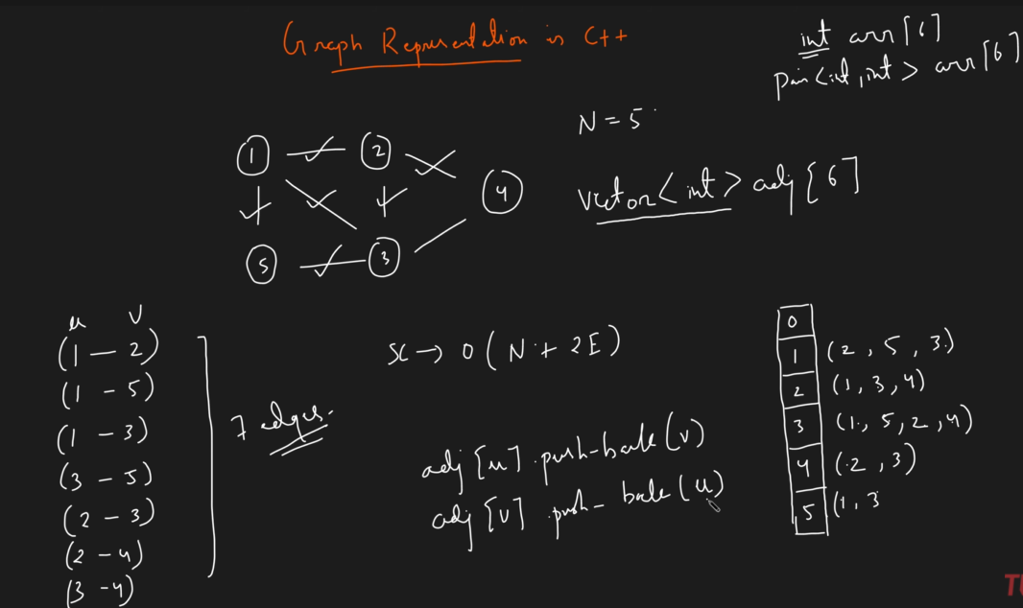

*This is for undirected graph (hence we are pushing edge to both nodes).

The space complexity required here will be **N + 2E (because we create an array of size N (or store N nodes) and in total we store 2E nodes (because twice of edges) ).**

**\*In case the edges have weights, we store pair<int,int> instead of int\***

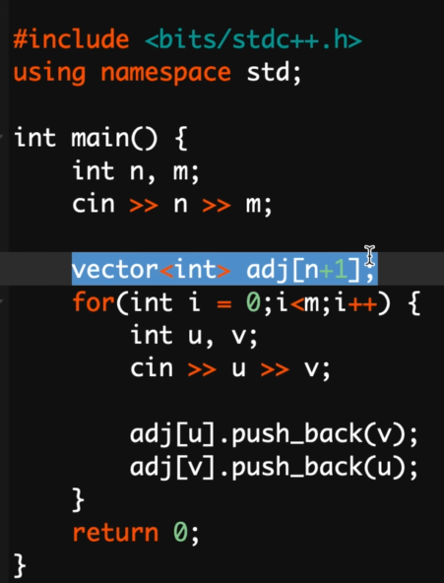

M is the number of edges and for each edge we are taking in two nodes, i.e., u and v respectively.

**\*For weighted graph use the below code\***

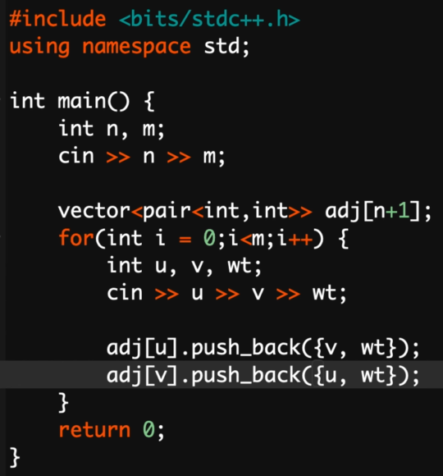

**Connected components in Graph**

A graph can have any number of components and a component can have any number of nodes. (In the following ss, the first 3 components add up to make a single graph and cannot be termed as 3 separate graphs)

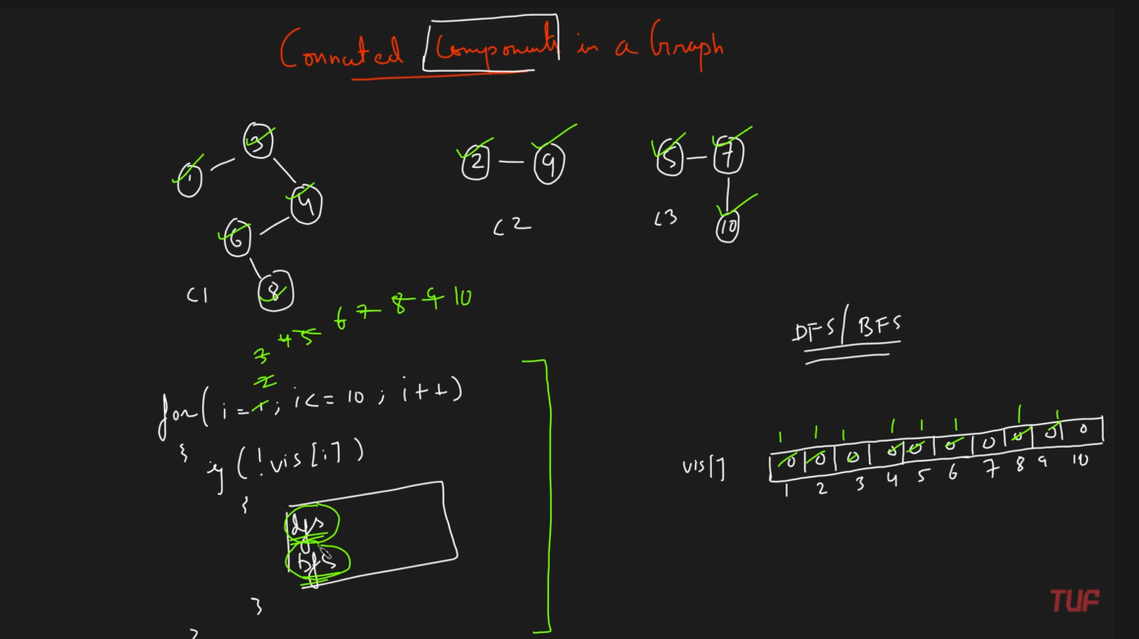

Since it has multiple components, we need to write this for loop (cant miss it else we might miss a component).

**Breadth First Search**

Traversing the adjacent nodes and then when we have traversed all the adjacent nodes we start traversing their adjacent nodes.

If the graph has a single component we can do a bfs right from the first node. However, for multiple components we always run a for loop to cover all the nodes and if a node is not visited, we call bfs on it (because if it would have been visited already then bfs would have been already called upon it).

We use the **queue** data structure to perform BFS.

1) We make a queue, take the first node, add it to the queue and mark it as visited.

2) We will iterate till the queue is not empty. Take the topmost element and pop it. Now mark it as visited (so that we don’t insert the same node again) and visit all of its adjacent neighbors and add it to the queue.

3) (If an adjacent neighbor is already visited don’t add it again to the queue). Whenever we pop a node from the queue, we can print it in the BFS order.

*For a single component, calling bfs on any node will lead to visiting all the nodes*

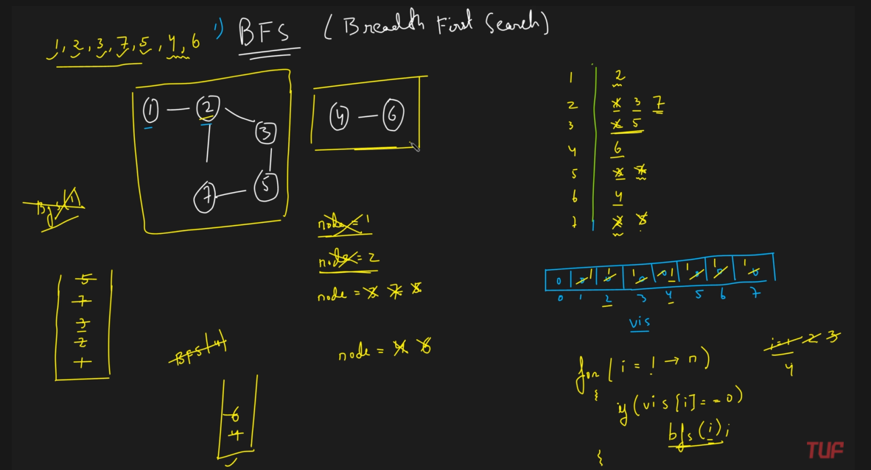

In the above figure, after component 1 is completely visited, the for loop runs till 4 and then we start performing BFS(4) just like we did BFS(1) to visit the complete component 1.

Time Complexity: **O(N+E)** at the worst case we are visiting n nodes in our bfs traversal. Yes we are traversing for the adjacent nodes, there is a loop running from 1 to n, but we are calling the bfs only for the number of components.

Space Complexity: **O(N)** using visited array and queue.

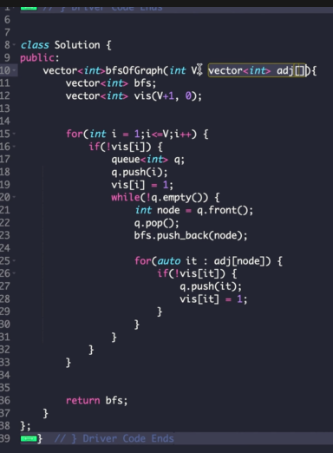

**Depth First Search**

Time Complexity: **O(N+E)** at the worst case we are visiting n nodes in our bfs traversal. Yes we are traversing for the adjacent nodes, there is a loop running from 1 to n, but we are calling the fs only for the number of components. **Time complexity is N+N = N because we are not calling dfs for all nodes but for only nodes of multiple components.**

Space Complexity: **O(N)** using visited array and queue.

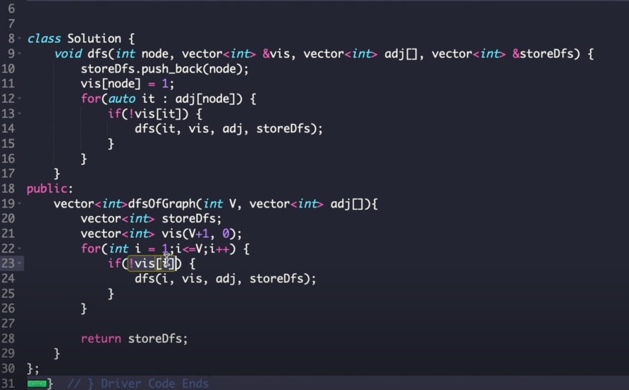

**Cycle detection in an undirected Graph using BFS**

In this we put the visiting node as well as the parent node in the queue.

This is because when we are on a node and we start to perform BFS on it, i.e., start exploring its neighbors there are 2 conditions. First, the node is already visited and it’s a parent node, in that case its not a cycle. However, if the adjacent node is already visited and not a parent node, in that case there is a cycle (because 1 visited is parent and second one is also visited meaning there is a cycle). For eg, consider visiting neighbors of 2 (1 already visited but a parent and 4 not visited, so not a cycle) in the following figure for not a cycle and visiting neighbors of 7 for a cycle (when we check its neighbors, 6 is already visited but is a parent, 8 on the other hand is also already visited (performed bfs on 9) and hence there is a cycle).

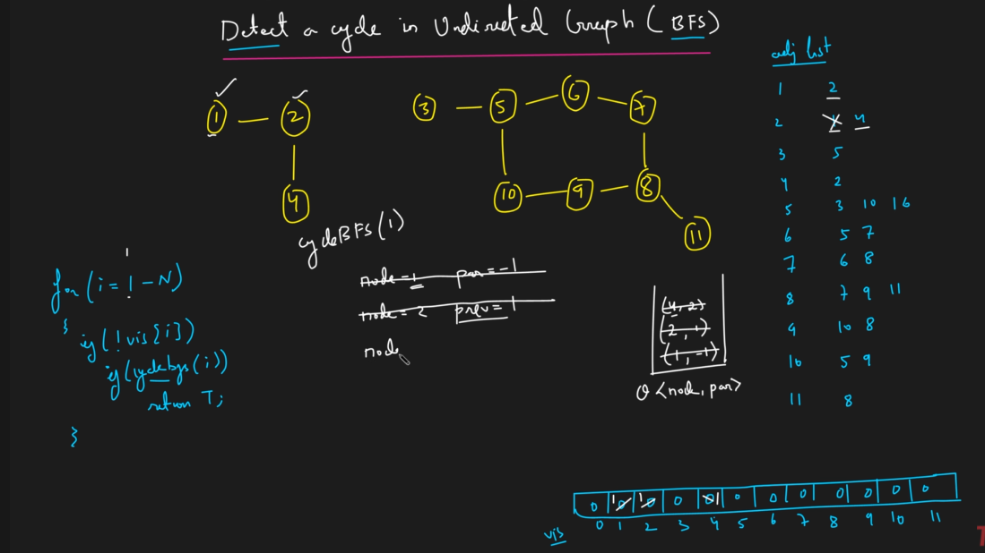

When we check if an adjacent node is visited or not, if its not, we mark it as visited and add it to the queue.

**Time Complexity: O(N)** since bfs also takes O(N).

**Space Complexity: O(N)** using array.

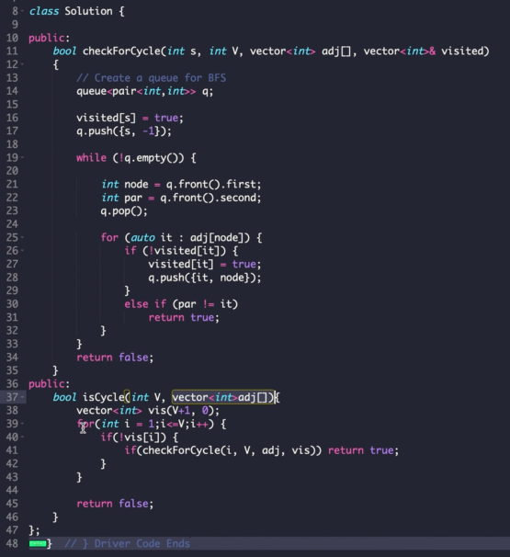

Line 30 means that if the adjacent node is visited but is not the parent then there is a cycle.

**Cycle detection in an undirected Graph using DFS**

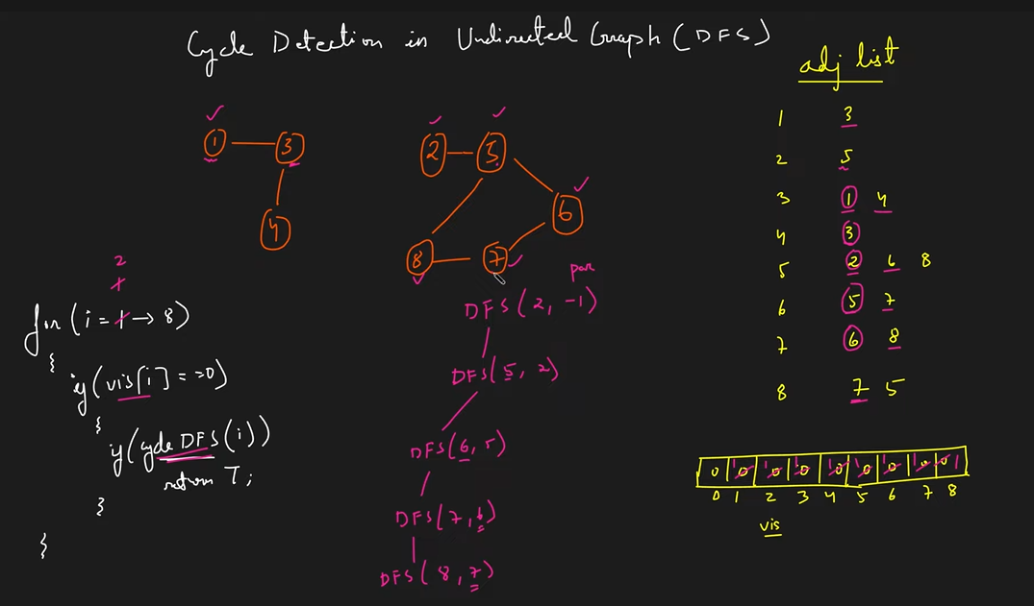

At 8, 7 and 5 both are visited. Any other node which is not the previous node if visited, causes cycle.

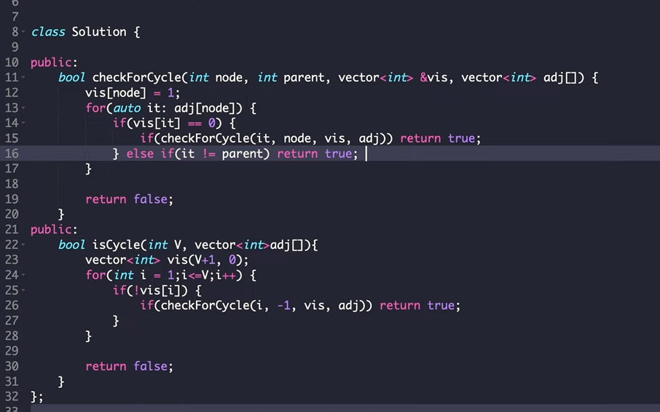

**Bipartite Graphs**

A graph that can be colored using exactly 2 colors and no two adjacent vertices have the same color.

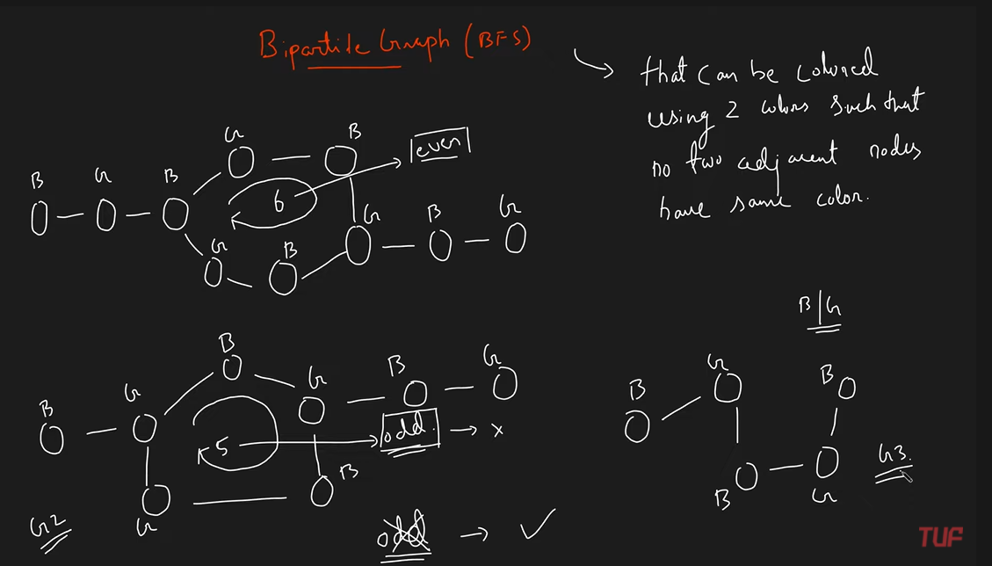

* Any graph with an odd length cycle cannot be bipartite. (Even length cycle or no cycle at all it is bipartite)

**BFS Traversal for checking if a graph is bipartite or not**

We start with a node and color it 0/1 and add it to the queue. Now we remove until queue is empty and for the removed element, we visit its adjacent nodes and color them with the opposite color and then put them in the queue (whenever we color a node, we add it to the queue). If an adjacent node is already coloured, we have to check whether it’s the same or different color. However, if the color matches the graph is not bipartite. (node 4 in the below figure)

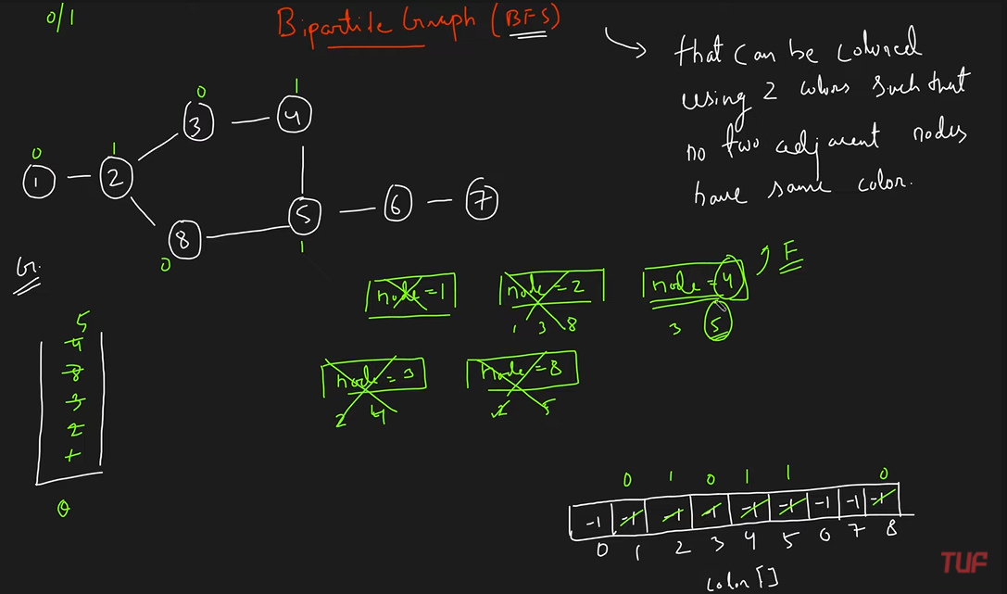

We make a color array of n size and initialize it with -1. The color array kind of acts like the visited array.

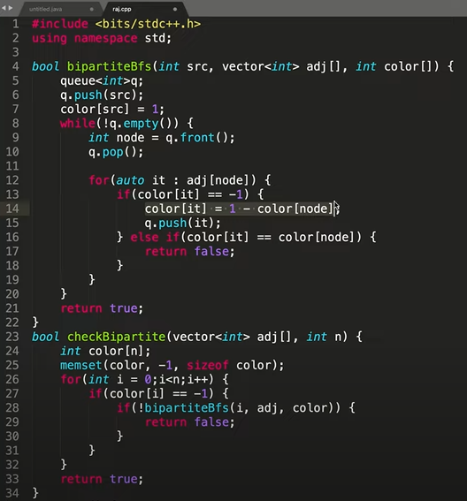

Line 13 is checking if the adjacent node is not colored then color it with the opposite color.

Line 16 is saying that if the adjacent node has the same color then the graph is not bipartite.

Line 28 check if any of the component is not bipartite, return false.

**bipartiteBfs()** is the bfs for each component.

**DFS Traversal for checking if a graph is bipartite or not**

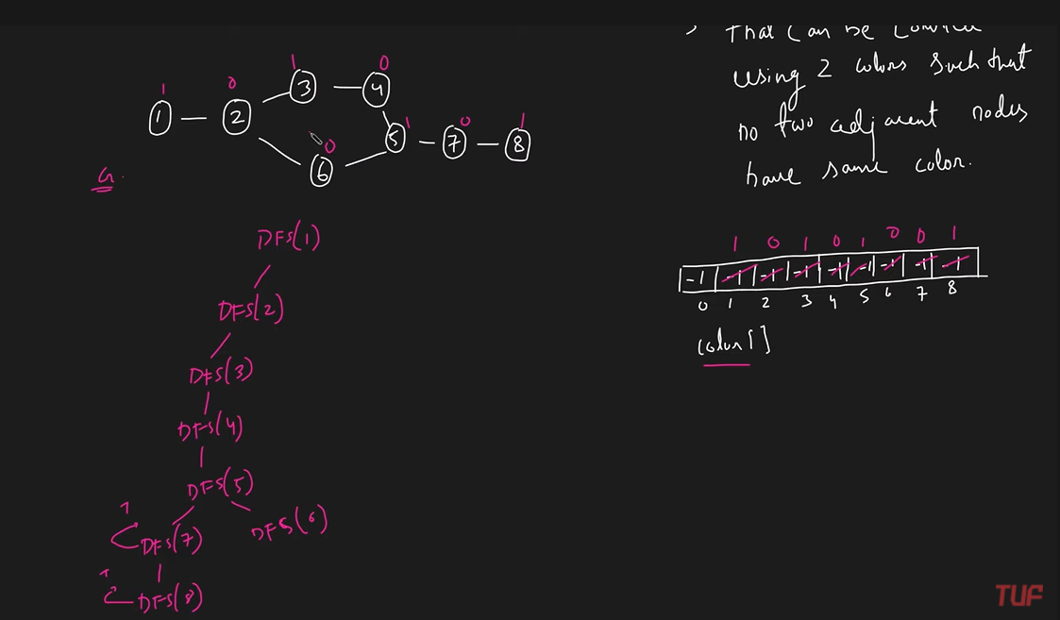

When 8 and 7 neighbors are done, they return true for the graph as bipartite. However, when 5 visits its another neighbor 6 and then 6 visits its neighbor 2, the color matches and it returns false. Since any one of them returned a false, we simply return false as a whole.

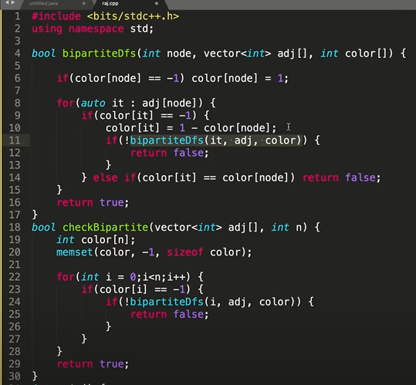

For loop on line 22 is written in order to perform dfs for multiple components (else we could have just performed dfs on any one node for a single component). However, for multiple components we need to perform dfs initially for multiple nodes.

Line 25 says if any component returns false, then return false (because all components combine to form 1 graph).

**Cycle Detection in Directed Graph using DFS**

The reason the same concept of undirected graph wont work is because therein we just made it clear that if we are re-visiting a node then it is a cycle (because the graph is undirected and hence there is a 2 way path). However, in the following figure if we mark 5 as visited when we perform dfs on 4 and later on when we perform dfs on 6 and encounter 5 as visited, we cant say there is a cycle (like we did in undirected graph, wherein any re-visit to an already visited node made it clear that there is a cycle).

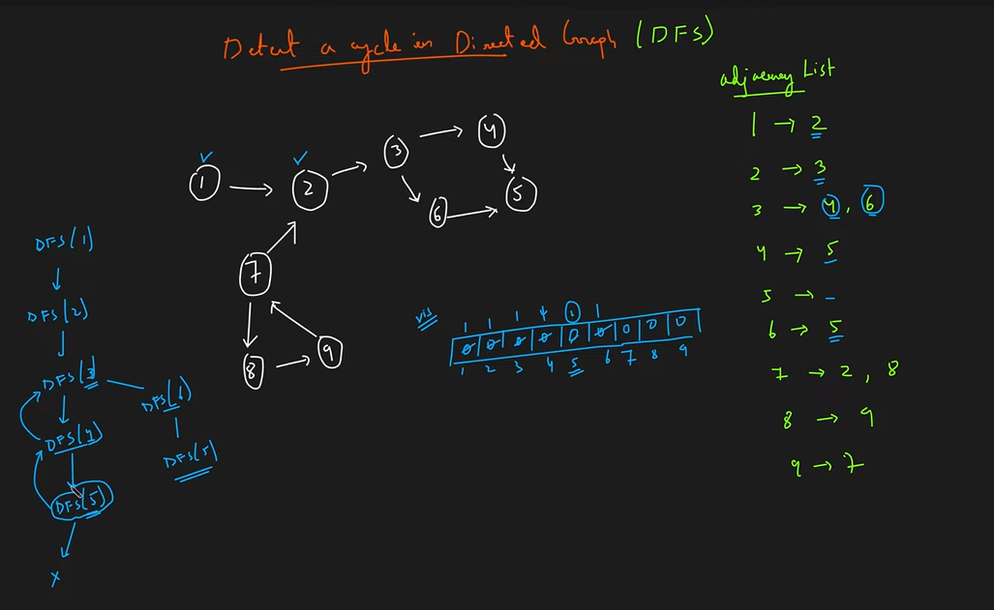

Hence, we have to use **self dfs** along with **visited dfs**.

We again mark as 1 whenever we visit a node both in the visited and self visited array.

Whenever a recursion call is over (in this case for a dfs) on a particular node, i.e., we have visited all of its neighbours its returning something and we are going upwards in the recursion tree, we mark as **0 for that node in the dfs visited array (because that dfs is over for that node). This is done so that we can keep a track of whether the node is visited in the directed graph. However, we don’t change the visited array.**

For example look at the node 5 below. When its neighbours are visited, we mark it as 0 in the self visited array and same for 4. Hence, now when we perform dfs on node 6, since we didn’t make a change in the normal visited array, we see that 5 has already been visited (in the visited array) and hence we don’t call a dfs on 5. However, since 5 has not been visited in the current dfs call (meaning that 5 has not been visited in the path we are traversing since we changed self dfs previously) we don’t get a cycle.

That’s why we are using **dfsVisited** to track whether the node was visited in the same dfs call or not.

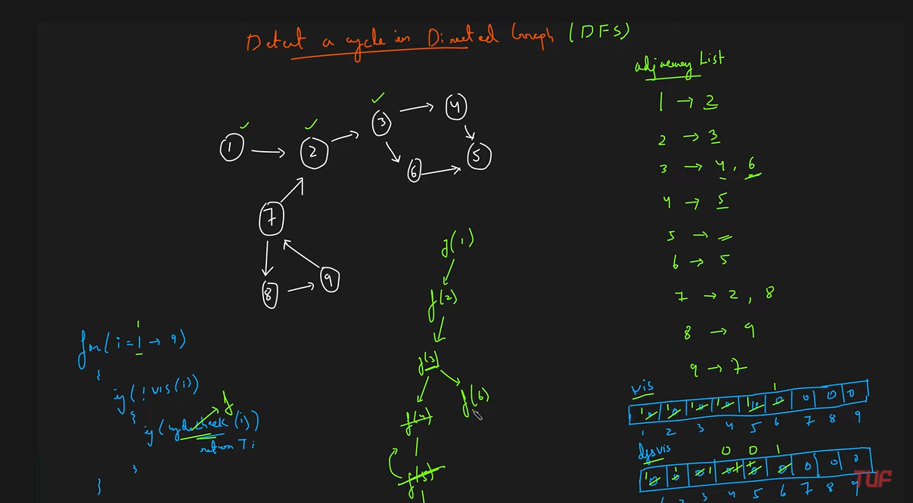

In short visited keeps track of the nodes on which dfs has been performed whereas, dfsVisited keeps track of the nodes visited in the current dfs search.

Now since there is another component consisting of 7,8,9 (since 7 has no incoming edge) hence we perform dfs on 7. However, we wont visit its neighbor 2 and perform dfs on 2 because its already present in the visited array, meaning dfs has been performed on 2.

However, when we reach 9 and check its adjacent neighbors, we find that 7 has been marked as visited in both the arrays, indicating that there is a cycle. Since 7 has been marked as 1 in the dfsVisited array, it means that the dfs call for 7 is not yet over and we have reached 7 again (hence we have reached a node which has been traversed in the current traversal) it is definitely a cycle.

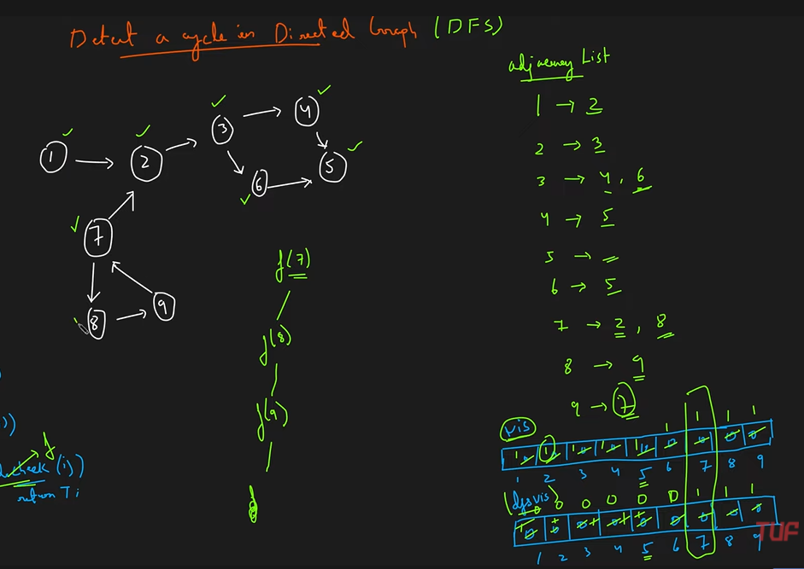

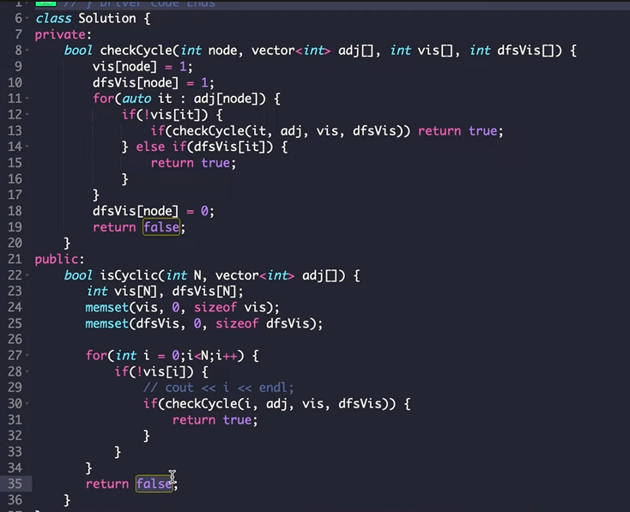

**Cycle Detection in Directed Graph using BFS**

A topological sort is only possible for an **Acyclic Directed Graph.**

Hence, we are gonna try to generate topological sort and if we are not able to generate it then we can conclude that it contains a cycle (basically using the reverse logic xD).

We have added a counter and if a topological sort is generated, then the number of nodes in that topological sort will be equal to the total number of nodes (since topological sort is a linear ordering of n). Hence, if we were able to generate a topological sort (then we can say that we were able to visit all the nodes), then **cnt == n** and hence we can say that it doesn’t have a cycle, else, it does.

**Topological Sorting**

Linear ordering of vertices such that if there is an edge u->v then u appear before v in that ordering.

1 example of the topological sorting can be 542310 because if we take an edge for example 4->0 then in the above ordering, 4 appears before 0. There can be multiple topological sort (however here we are sure that for this topological sort, the vertex u always appears before v)

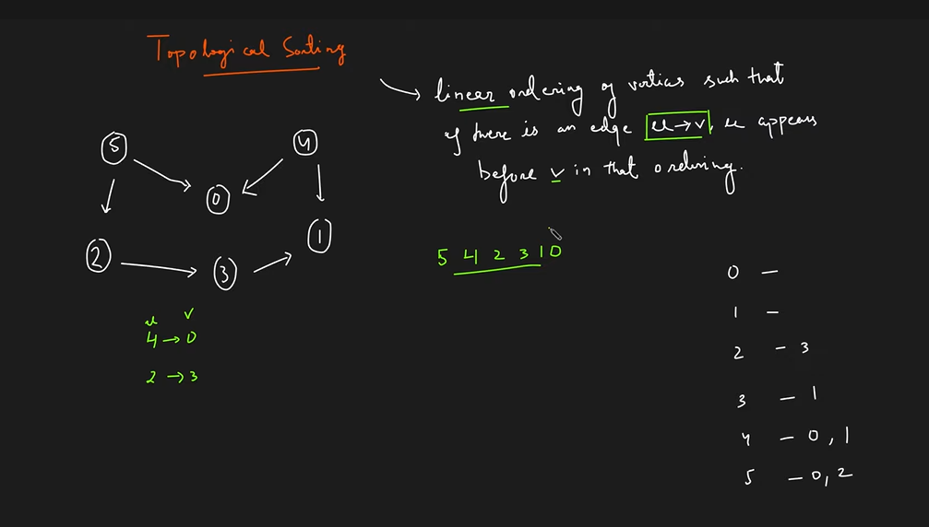

There can be multiple topo sort for a given graph (only condition is that for an edge u->v, u should appear v).

This is for DAG (directed because if its undirected we cant specify which edge between the vertices u <-> v should be considered while ordering.

Acyclic because for the below example we cant write a topo sort:

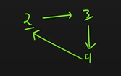

**DFS Algorithm for Topo Sorting**

We loop through all nodes and if its unvisited, we call dfs on it.

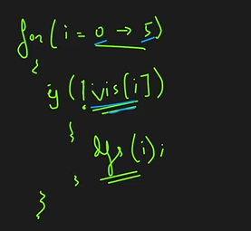

We take a visited array and a stack. Whenever the dfs recursion call for a node is exhausted, we add it to the stack. That’s why 3 is added to the stack before 2 because its dfs call got exhausted earlier. Hence, the stack is now topo-sorted.

Hence, we are traversing dfs in such a way that if there is an edge from u->v then it the dfs call for v is bound to happen prior to that of u and hence it will get added to the stack before u.

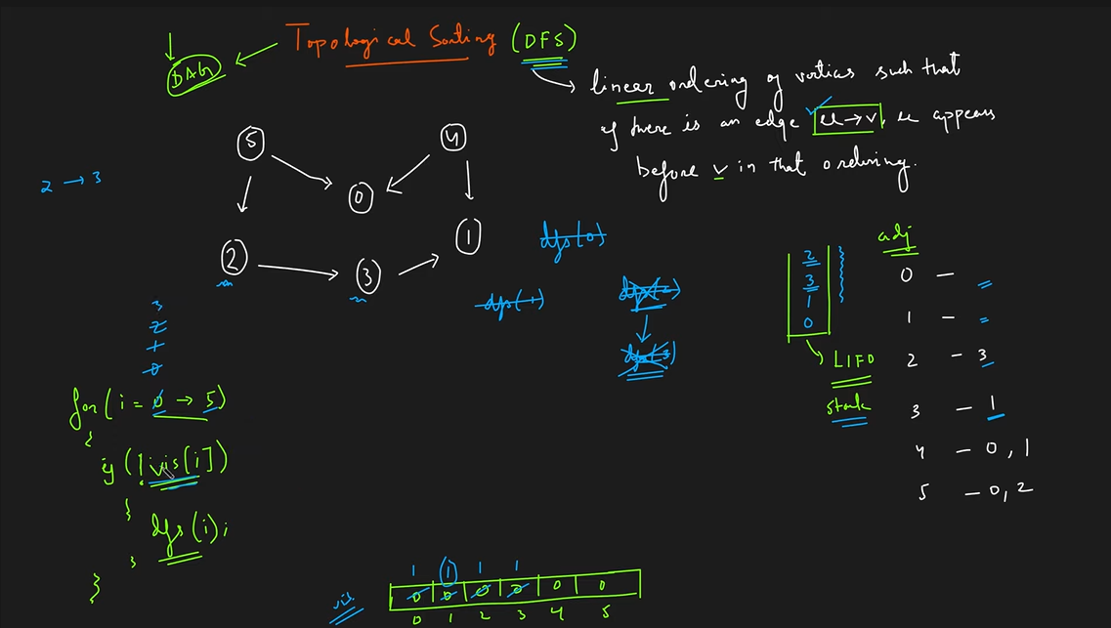

(0 and 1 had no neighbors and hence their dfs call was exhausted immediately leading to their addition within the stack) Also we didn’t call 1 after 3 because it was already visited and hence there’s no point performing dfs on 1 again.

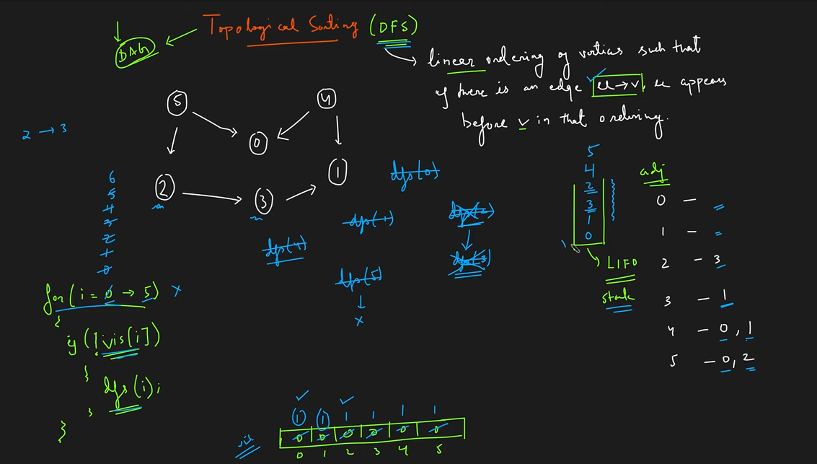

Finally we get the stack and we can pop it to get our answer. This is 1 of the many topo sorts possible for this graph.

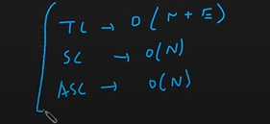

Asc = auxiliary space complexity for the stack.

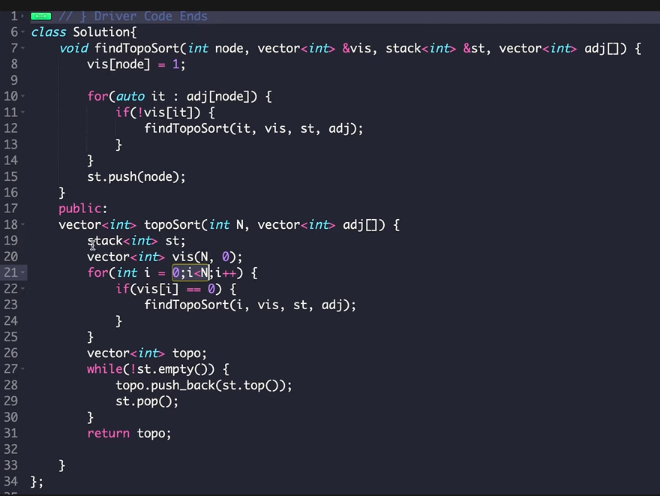

Line 22 (whichever node is not visited, call dfs for that).

Line 10-12 (visiting neighbors and if not already visited, call dfs on them).

Line 15 (whenever dfs call is over for a particular node we push it to the stack) // only thing different from a normal dfs

**BFS Algorithm for Topo Sorting**

We require 2 things, first of all an array with the in-degree of all the vertices and secondly the queue data structure.

1) Now traverse the array with the in-degrees and push all the nodes with 0 in-degree within the queue.

2) Now implement bfs algo using this queue. (whenever we pop a node from the queue to perform BFS on it, we add it to our topo sort list)

3) After popping an element from the queue and adding it to the topo sort list, we start visiting its neighbors and reduce their in-degree by 1 in the array of in-degrees.

4) Now check for the nodes whose indegree we decremented by 1 that whether their indegree has turned to 0 or not. If not, simple pop the next element of the queue and repeat steps 2 and 3 else add them to the queue.

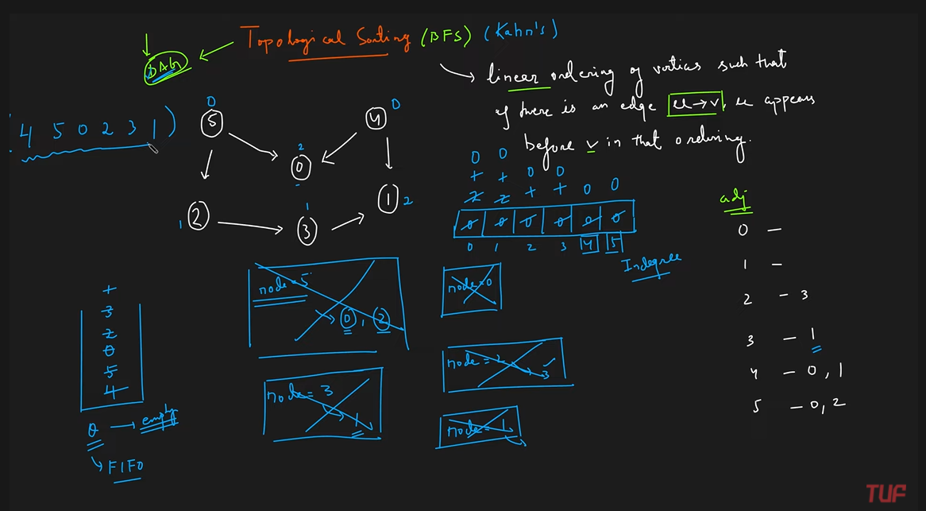

We can see that the topo sort always starts with the nodes having an indegree of 0.

The reason for subtracting 1 from the indegree of the adjacent nodes is that in the start when we popped 4 and added it to the topo sort list, we can see that 4 was having a dependency factor on 0 and 1 (because it had an out-degree to 0 and 1) and since 4 has been written in the topo list, we cut off these edges and decrease the in degrees. **Basically we are removing a node and hence terminating all of its edges due to which we have to reduce the in degree of the nodes dependent on it. This will ultimately lead us to getting nodes which were dependent on the previous nodes which are already present in the topo sort list and hence we get the required topological sorting array.**

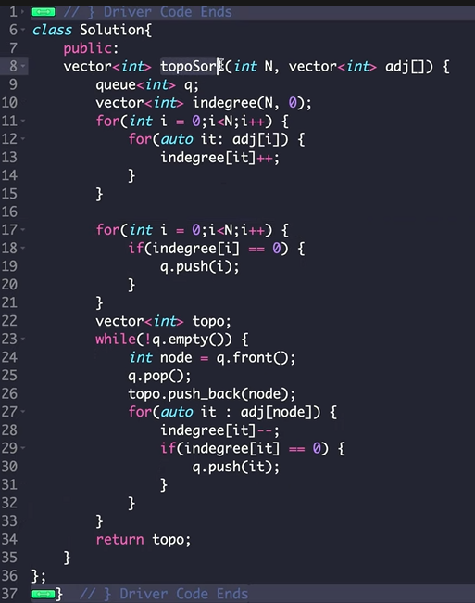

**Line 11-13: calculating indegrees.**

**Line 17-20: adding elements to the queue initially.**

**Line 24-30: rest.**

**Shortest path in an undirected graph (unit weights)**

We make use of BFS to find the shortest distance and make some changes to it.

1) Initially take a distance array of size N and mark all indexes as infinity.

2) Take a queue data structure which stores the nodes. Initially, put the source node in the queue and mark the distance of this node as 0 in the distance array (because to travel to the source node itself we need to travel 0 distance).

3) Visit the adjacent nodes and then add them to the queue. Also, calculate new distance to the adjacent nodes as **distance to node whose bfs we are performing + 1** and compare it to the previously stored distance to that node in the distance array. Keep the minimum of the two distances. **Note that we only add a node to the queue if we updated its distance in the distances array (this is what will lead to termination of items in queue).**

In the following figure when we start with node 0, we **calculate** distances of node 1 and 3 as 1 which is less than infinity and mark distances of node 1 and 3 as 1 in the distances array. Then, when we traverse 1, we don’t update distance of node 3 as 2 (since its 1 which is less than 2) and only update distance of node 2 as 1+1 < infinity.

When the queue is empty, the distances array will contain the shortest distance from the start to every other node.

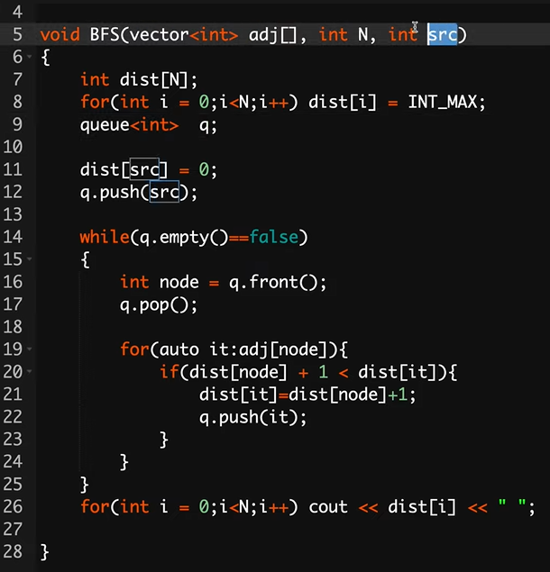

**Shortest Path in Weighted Directed Acyclic Graph**

Here we need to store a vector<pair<int,int>> for the input.

1) Using a visited array, find the topo sort.

2) Now making another array which will allow you to store the weights. Initialize all indexes with infinity and mark node as 0.

3) Pop the elements in the order of their topo sort and visit their adjacent nodes and update the distances in the distances array. (the logic is that since the elements which appear early in the topo sort list have a lesser number of in-degree, it means they have more paths outgoing and hence we can get the paths)

So we used dfs to get topo sort and then bfs on the elements in the topo order.

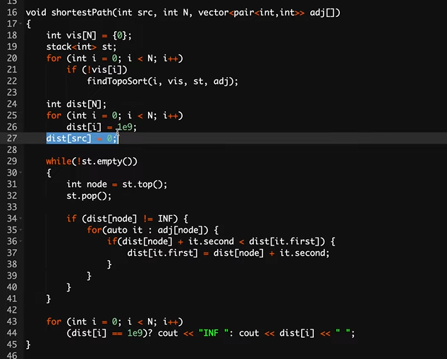

First we find the toposort array. Next we make a distances array and mark all distances as 1e9. Now initialize index 0 with distance 0 (starting). Now till !stack.Empty() (containing topo sort) If the node is not infinity, meaning we have reached it previously, only then we can traverse its neighbor nodes (because if the node itself has distance as infinity then it means we never reached it). Next we do auto it: adj[node] and calculate distance and replace it depending on whether its small than the current distance or not.

**Dijkstra's Algorithm | Shortest Path in Undirected Graphs**

If we apply BFS using queue here (like we did earlier), we wont get our desired answer because earlier the edge weights were given as 1, whereas now they are not of unit weights.

We use a minimum heap (priority queue) which stores **(distance, node)** so that the node with the smallest distance is always at the top and a distance array.

1) Initialization is done by changing distance of the starting node to 0 in the distance array and then adding it to the queue with distance as 0 and node as starting node. (now we perform bfs using this queue)

2) Pop the first element from the queue and perform bfs on it. If for the adjacent nodes we get a smaller path, we update their distances in the distance array and add them to the priority queue (only if the distance is updated in the distances array, we add it to the priority queue).

Repeat until (priority) queue is empty.

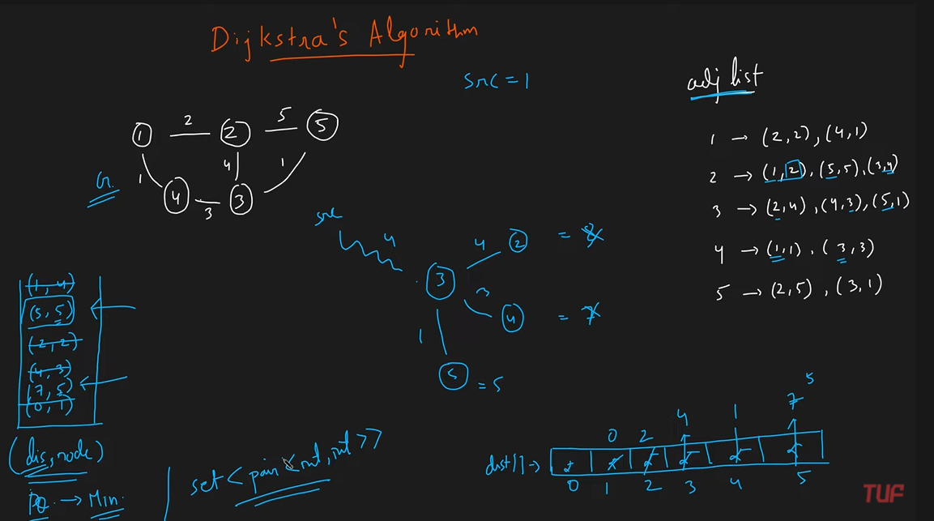

At last we see the queue consists of two distances for node 5 with the minimum at the top. That’s the reason of using priority queue because we will always get the answer with the lesser distance for a particular node (since we have to reach 5 anyhow, a lower distance will give us the better answer)

**Time Complexity: O(N+E)*logN // in the priority queue I’m traversing N nodes (within the queue) and E edges in total and logN for priority queue implementation**

**Space Complexity: O(N) + O(N) // array + queue**

#include<bits/stdc++.h>

using namespace std;

int main(){

    int n,m,source;

    cin >> n >> m;

    vector<pair<int,int> > g[n+1];  // 1-indexed adjacency list for of graph

    int a,b,wt;

    for(int i = 0; i<m ; i++){

        cin >> a >> b >> wt;

        g[a].push_back(make_pair(b,wt));

        g[b].push_back(make_pair(a,wt));

    }

    cin >> source;

    // Dijkstra's algorithm begins from here

    priority_queue<pair<int,int>,vector<pair<int,int> >,greater<pair<int,int> > > pq;// min-heap ; In pair => (dist,from)

    vector<int> distTo(n+1,INT_MAX);    // 1-indexed array for calculating shortest paths;

    distTo[source] = 0;

    pq.push(make_pair(0,source));   // (dist,from)

    while( !pq.empty() ){ // traversing complete pq

        int dist = pq.top().first;

        int prev = pq.top().second;

        pq.pop();

        vector<pair<int,int> >::iterator it;

        for( auto it : g[prev]){

            int next = it.first;

            int nextDist = it.second;

            if( distTo[next] > dist + nextDist){

                distTo[next] = distTo[prev] + nextDist;

                pq.push(make_pair(distTo[next], next));

            }

        }

    }

    cout << "The distances from source, " << source << ", are : \n";

    for(int i = 1 ; i<=n ; i++) cout << distTo[i] << " ";

    cout << "\n";

    return 0; }

**Minimum Spanning Tree**

Graph needs to be a weighted graph.

When we can convert a graph into a tree such that there are N nodes and N-1 edges and every node is reachable by every other node, it is known as a spanning tree.

It is known as minimum spanning tree when the distance is minimum.

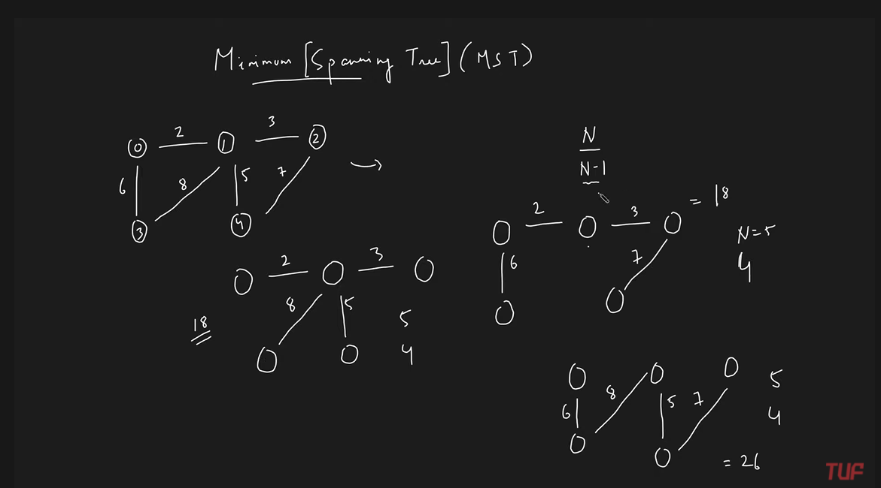

**Prim’s Algorithm**

Starts with the initial nodes and then picks up the edge with the least weight. Now, among the 2 vertices, it checks all the edges of these 2 vertices to get the one with the least weight. Now we have 3 vertices and we do the same until we get our desired result (all nodes have been connected).

In the following figure, first we pick up vertex 0 and select its closest edge. Then among 0 and 1, we pick up the smallest edge. Repeat this.

**Note that we cant pick an edge if it forms a cycle. That’s the reason we didn’t pick the edge 2-4 in figure 2.**

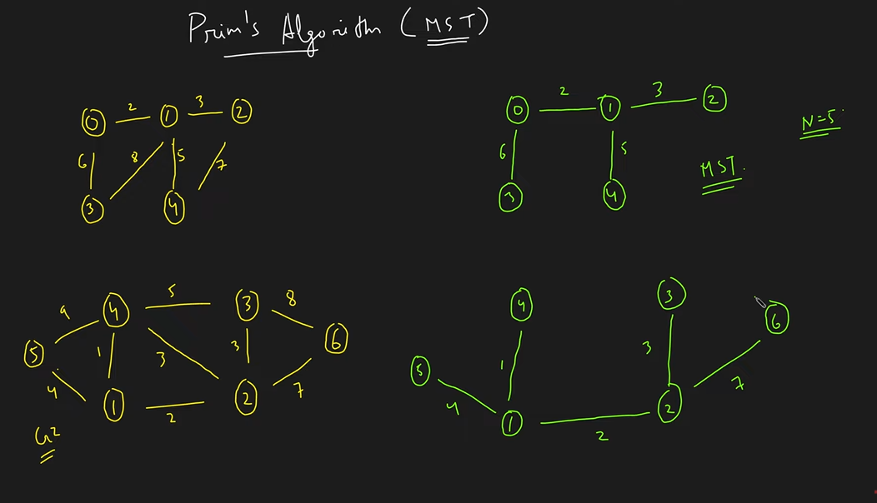

To implement prims algorithm, we need 3 arrays:

1) Key array: everything except index 0 is initialised with infinity.

2) Mst array: all set to false.

3) Parent array: all set as -1.

Step 1: Find the index with the minimum key value and not a part of the MST. (Hence, initially node 0 was given a key value of 0 and also is false in the MST, so we start from this node) The moment we get the minimum key value node, mark it as true in the MST.

Step 2: Checkout its adjacent nodes. We visit 1 and 3, modify their weights in the key array and also their parent in the parent’s array. However, we don’t do anything yet in the mst array.

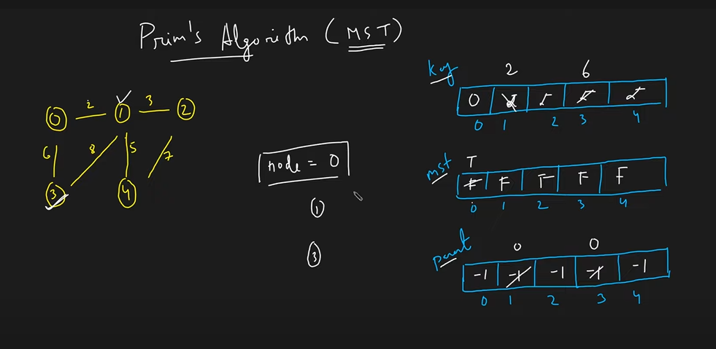

Hence, for the first node we took, we made sure that its adjacent edges are marked in the key. So, once we have the values in the key’s array, we can look for the next minimum key value in the key array **which is not a part of the MST (this helps to avoid repetition of nodes)**.

Step 3: Now we pick up node 1 since it has a least weight and mark it as true in the MST.

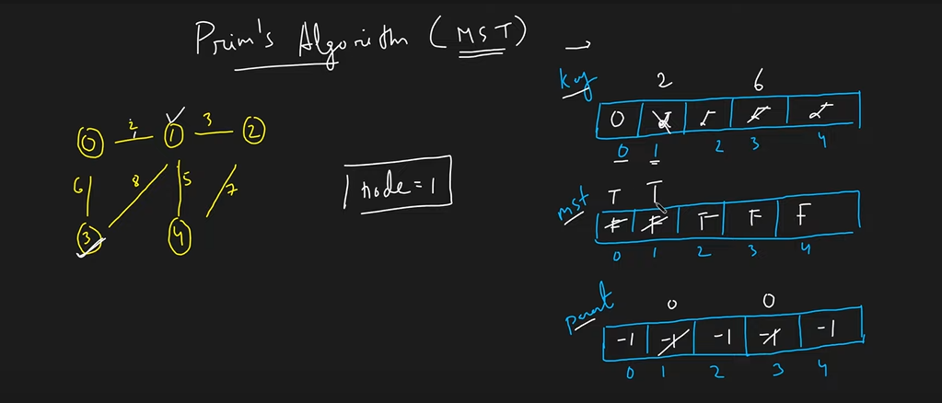

For node 1, node 0 is already true in the MST and hence we don’t check the weight for it. For weight to node 3, the weight is already less and hence no need of updating it. However, for node 2 and 4 we perform the required changes in the key and parent key.

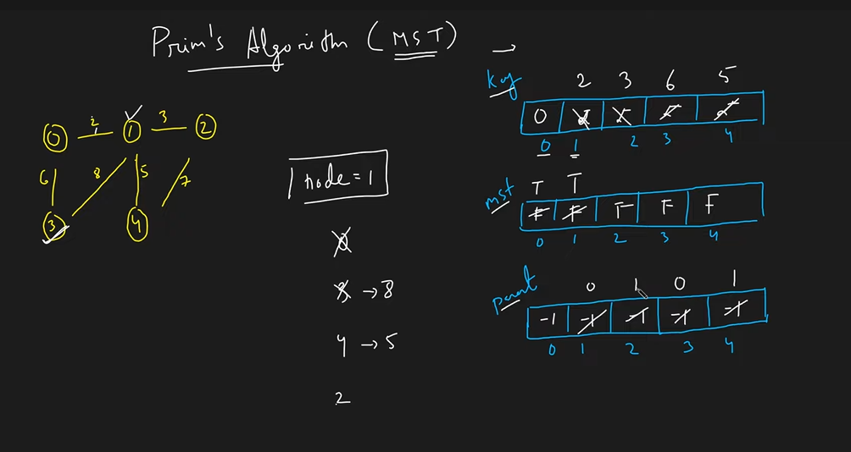

Step 4: Iterate over key array and find the minimal value and not a part of the mst and repeat the above steps.

Final…

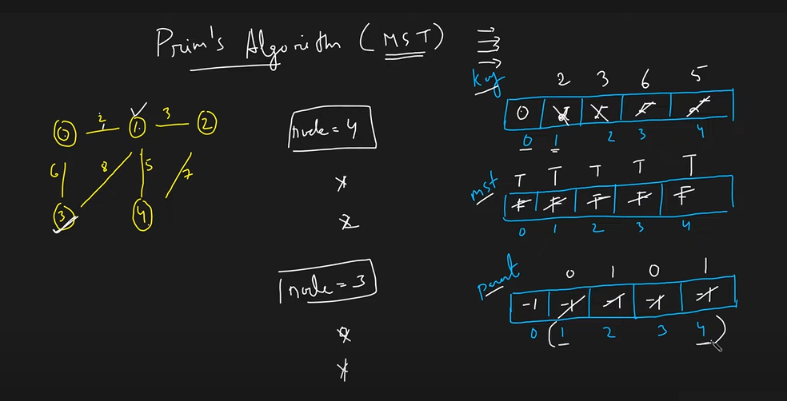

Once the mst is completed, in order to get the edges of the MST we iterate from 1 to 4 because we started from 0 and it had no parent. **We use the parent array to generate the required minimum spanning tree.**

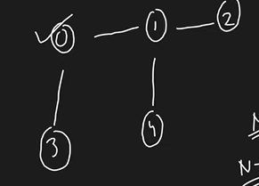

**Hence, the intuition of the algorithm was that we started with the single node and then picked up the edges with the minimum weight and expanded the tree (repeating this till we got N nodes and N-1 edges).**

**Code**

**1) Brute force approach**

We take input as an adjacency list.

#include<bits/stdc++.h>

using namespace std;

int main(){

    int N,m;

    cin >> N >> m;

    vector<pair<int,int> > adj[N];

    int a,b,wt;

    for(int i = 0; i<m ; i++){

        cin >> a >> b >> wt;

        adj[a].push_back(make_pair(b,wt));

        adj[b].push_back(make_pair(a,wt));

    }

    int parent[N];

    int key[N];

    bool mstSet[N];

    // Running for N time

    for (int i = 0; i < N; i++)

        key[i] = INT_MAX, mstSet[i] = false;

    key[0] = 0;

    parent[0] = -1;

    int ansWeight = 0;

    // Running for N time

    for (int count = 0; count < N - 1; count++) // iterating for N-1 edges (because we will have N-1 edges in our MST)

    {

        int mini = INT_MAX, u;

        // finding the minimum key (distance)

        for (int v = 0; v < N; v++)

            if (mstSet[v] == false && key[v] < mini)

                mini = key[v], u = v;

        mstSet[u] = true; // setting its visited to true

        // iterate for it's adjacent nodes

        for (auto it : adj[u]) {

            int v = it.first;

            int weight = it.second;

            if (mstSet[v] == false && weight < key[v]) // if not visited and calculated weight is lesser than the previous weight

                parent[v] = u, key[v] = weight;

        }

    }

    for (int i = 1; i < N; i++)

        cout << parent[i] << " - " << i <<" \n";

    return 0;

}

**Time complexity: O(N^2 + E) (Third for loop of adjacent vertices doesn’t make it N^3 because if we are traversing the adjacent nodes of all nodes then that’s not N^2 but N+E)**

**2) Optimized Approach**

Use priority queue to get minimum value of key in log(N).

#include<bits/stdc++.h>

using namespace std;

int main(){

    int N,m;

    cin >> N >> m;

    vector<pair<int,int> > adj[N];

    int a,b,wt;

    for(int i = 0; i<m ; i++){

        cin >> a >> b >> wt;

        adj[a].push_back(make_pair(b,wt));

        adj[b].push_back(make_pair(a,wt));

    }

    int parent[N];

    int key[N];

    bool mstSet[N];

    for (int i = 0; i < N; i++)

        key[i] = INT_MAX, mstSet[i] = false;

    priority_queue< pair<int,int>, vector <pair<int,int>> , greater<pair<int,int>> > pq;

    key[0] = 0;

    parent[0] = -1;

    pq.push({0, 0}); // storing value of key as 0 for index/node 0

    // Run the loop till all the nodes have been visited

    // because in the brute code we checked for mstSet[node] == false while computing the minimum

    // but here we simply take the minimal from the priority queue, so a lot of times a node might be taken twice

    // hence its better to keep running till all the nodes have been taken.

    // try the following case:

    // Credits: Srejan Bera

    // 6 7

    // 0 1 5

    // 0 2 10

    // 0 3 100

    // 1 3 50

    // 1 4 200

    // 3 4 250

    // 4 5 50

    while(!pq.empty())

    {

        int u = pq.top().second; // (instead of iterating over the key array we pick the second element of line 29 because thats the index which

        // has the minimum value) Hence we replaced for loop with a heap

        pq.pop();

        mstSet[u] = true;

        for (auto it : adj[u]) {

            int v = it.first;

            int weight = it.second;

            if (mstSet[v] == false && weight < key[v]) {

                parent[v] = u;

        key[v] = weight;

                pq.push({key[v], v});

            }

        }

    }

    for (int i = 1; i < N; i++)

        cout << parent[i] << " - " << i <<" \n";

    return 0; }

**Time Complexity: O(N + E) + O(NlogN) => O(NlogN)**

**Disjoint Set Data Structure (Used in Kruskals)**

Used to tell whether 2 given nodes belong to the same component or not.

This DS provides 2 different operations: find parent and union.

Initially we are given 7 components wherein each node is a parent of itself.

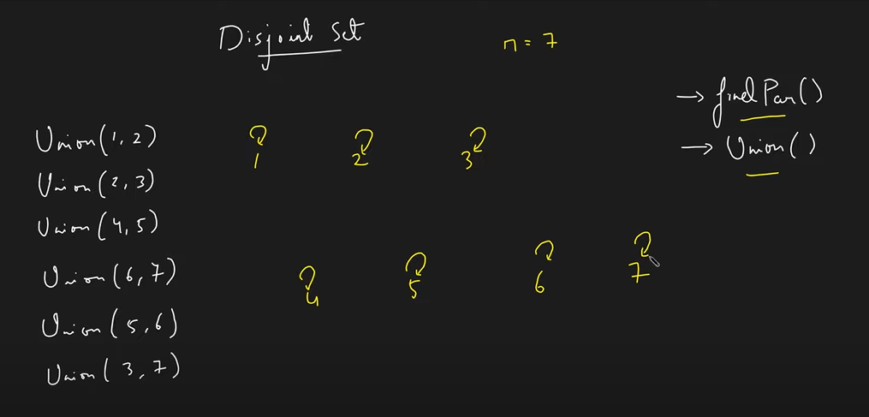

Union(1,2) means that the component to which 1 belongs and to which 2 belongs should be attached. Since, we cant have different parent for a single component, we make 1 as the parent of 2 aswell.

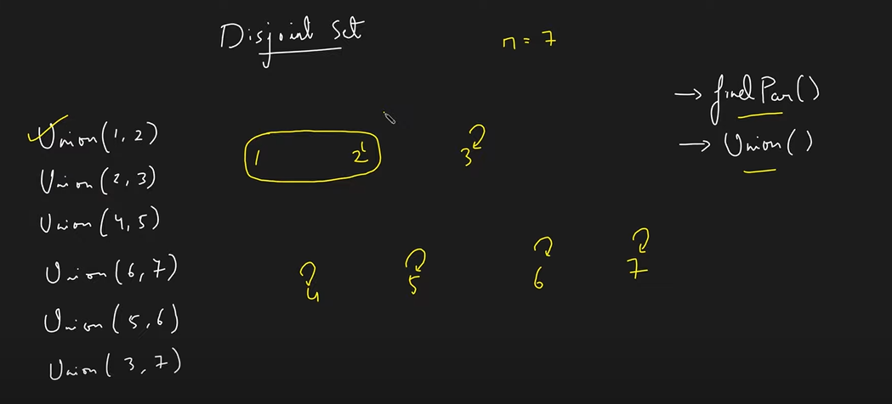

Union(2,3) means component to which 2 and 3 are attached should be combined.

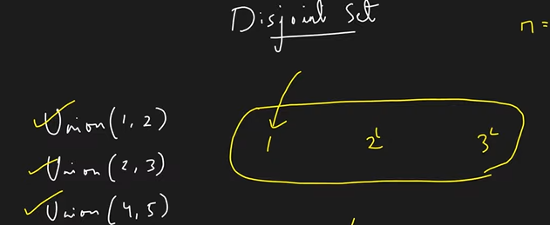

In the second last time when we want to combine the component containing 5 (4 and 5) and the component containing 6 (6 and 7), then we make 4 as the parent for 6 aswell (6 is the parent of 7 and 4 the parent of 5).

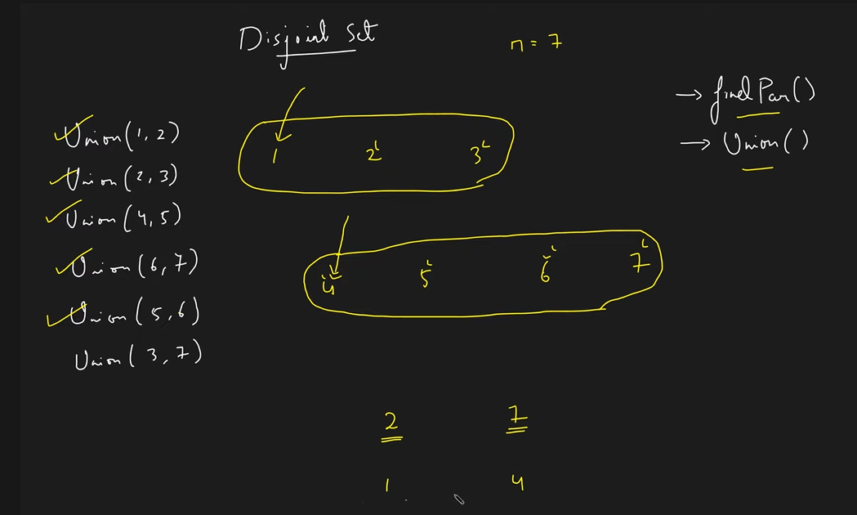

Before the last step if we wanna check whether 2 and 7 belong to a single component or not, we check their parent and since they are different, we return false.

After last step 1 becomes the parent of 4 aswell.

Disjoint Set

1) When we want to combine the component containing 1 and 2, we first figure out their parents and then compare their ranks. Incase the ranks are equal, we can make any of them the parent of the other one.

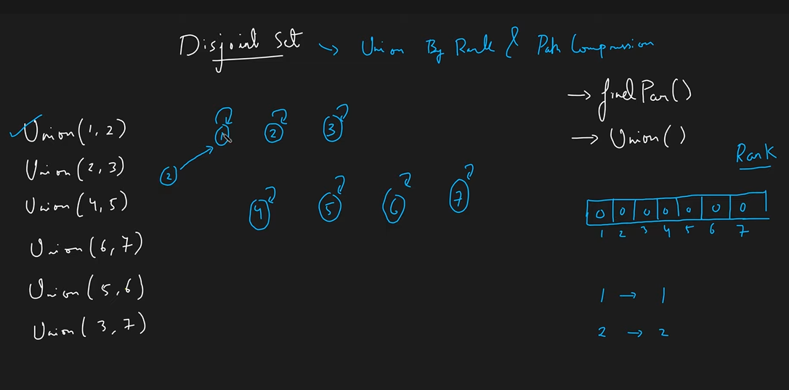

We attached node 2 to node 1 and to the node which we are attaching to, increase its rank by 1.

Now to perform U(2,3) we don’t connect 2 and 3 directly. First find the parent of 2 and 3 and then compare rank of parents. Connect smaller rank component to the larger rank.

If we do using this concept then this is the tree size.

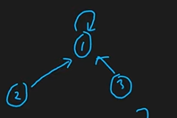

However, if we attach the higher rank component to the lower rank component, then the tree length gets elongated. Hence, the next time we would have needed to find the parent of 2, it would first return 1 as the parent of 2 and then 3 as the parent of 1, thereby increasing the depth of the tree, i.e., time complexity.

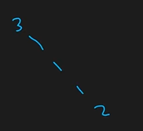

**However, since the ranks of 1 and 3 were different we don’t increase the rank (this is because when we attach a lower rank node to a higher rank node, the height of the tree does not increase). On the other hand, when the ranks are equal, we increase the rank by 1 since the height increases.**

Now when we want to combine 5 and 6, then we see parent of 5 which is 4 with a rank 1 and parent of 6 which is 6 itself having a rank of 1. Hence, we combine 6 to 4 and increase rank of 4 by 1.

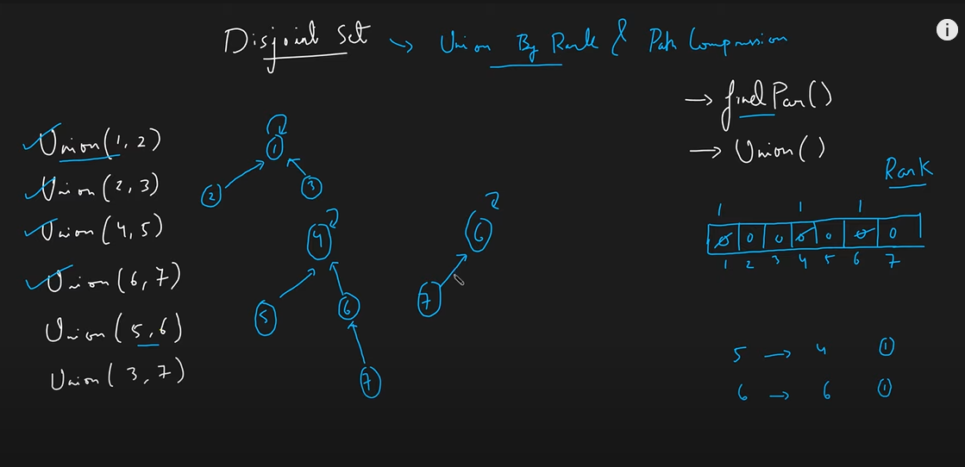

Now in the final step when we have to take the union of 3 and 7, we find the parent of 3 which is 1 and then find the parent of 7 which is at the end 4.

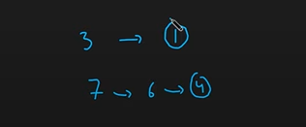

Till now we have been performing **union by rank**, however now its time to implement **path compression**. While figuring out the parent of 7 we had to go to 6 and then 4. In the next step let us say we again want to perform a union of 7 with another node, then we will again traverse from 7 to 6 to 4. However, since we already know from the previous step that the final parent of 7 is 4, why not directly make use of this fact.

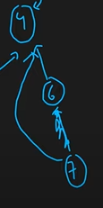

Hence, once we figure out that the parent of 7 is 4, we can directly go from 7 to 4 next time without going to 6 in between. Hence, next time when someone asks the parent of 7, we can directly tell it to be 4 without traversing 6. Hence, **path compression allows us to minimize the movement while finding parent of a node.**

Hence, we attach 7 to 4 like this.

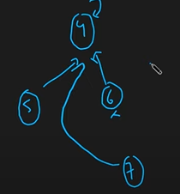

After the last union we get the following:

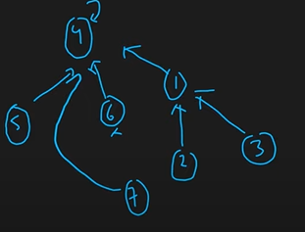

We can again do path compression whenever we check for parent of a node. For example if someone asks us the parent of 3, then we traverse as 3-1-4 but later update it to 3-4, thereby directly linking it.

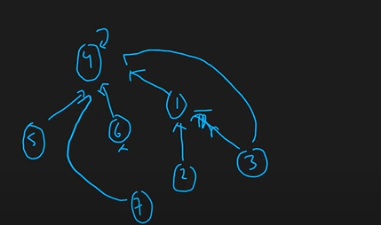

Hence, this was the disjoint set implementation.

Time complexity: O(number of unions)

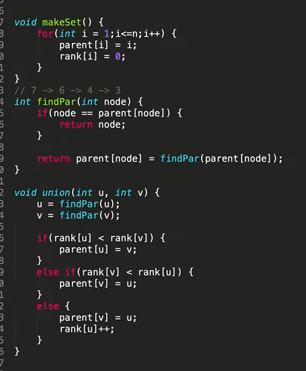

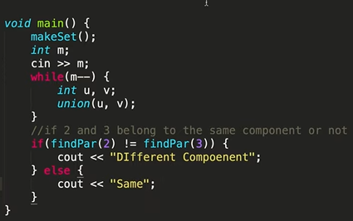

findPar() works in O(4alpha).

If we don’t use path compression then it works in 0(logN).

**Kruskal’s Algorithm to get MST**

Uses disjoint set data structure to find the minimum spanning tree (MST).

Step 1: Here we wont store the graph as an adjacency list but rather as a normal linear data structure. (This is because we want to store the edges in the sorted order of their weights as first step in kruskal’s algorithm) In the below figure we have sorted all the edges wrt their weights (first index = weight).

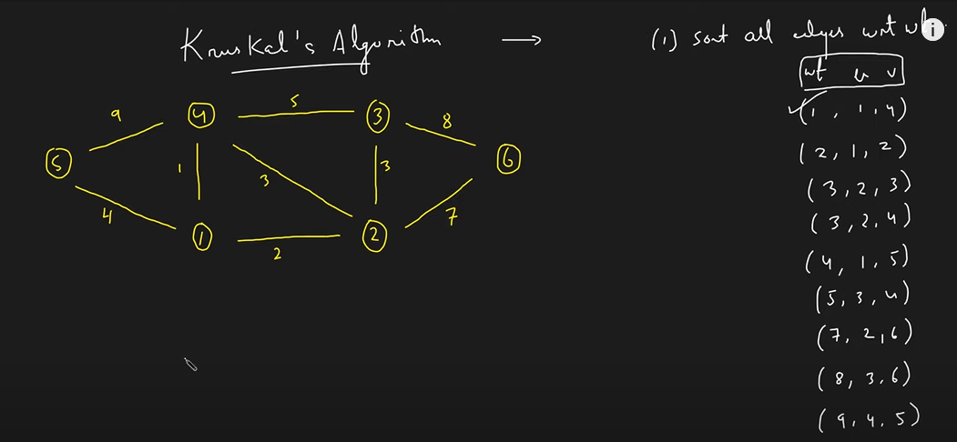

Step 2: Greedily pickup the shortest edge (1-4). Now check whether 1 and 4 belong to the same component or not using disjoin set. They don’t and so we can pick up this edge.

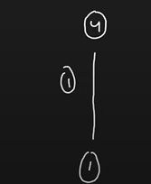

Step 3: Greedily pickup the next edge (1-2). They don’t belong to the different component (before attaching).

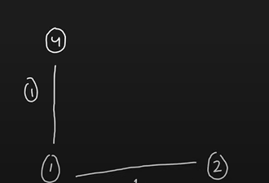

Step 4: Repeat the steps by finding the minimum distance edge greedily and checking whether the two nodes of the minimum edge weight we have picked belong to the newly (in construction) component being generated by us or not. It is necessary that we don’t connect edges wherein the nodes belong to the same component (since we are making a MST, we can’t have loops as we are forming a tree).

**Hence, the mst concept stays as we are greedily picking up the edges and also making sure they do not form a loop using the disjoint set data structure.**

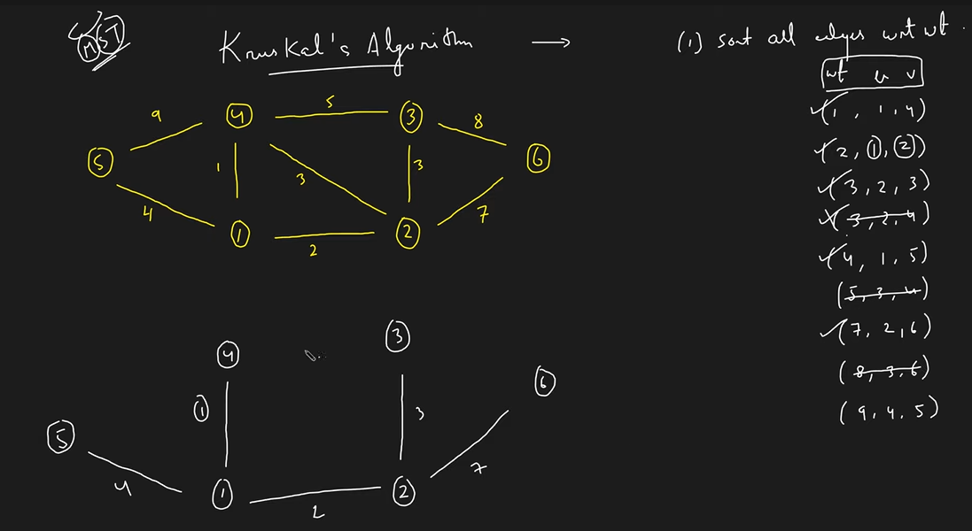

**Note that we didn’t take the 5th, 7th and the last two edges because the nodes within them belong to the same newly created component (as they have the same parent).**

**Hence, we generated our MST by greedily picking up the edges and then checking whether the two nodes belong to the same component or not in order to prevent any loops.**

**Time complexity:** O(MlogM) + O(M * O(4alpha)) => O(MlogM) // m = edges, MlogM is to sort the edges + iterating over these M edges and checking whether they belong to the same component or not.

**Space complexity:** O(M) + O(N) + O(N) // N for ranks and parents and M for edges sorted.

#include<bits/stdc++.h>

using namespace std;

struct node {

    int u;

    int v;

    int wt;

    node(int first, int second, int weight) {

        u = first;

        v = second;

        wt = weight;

    }

};

bool comp(node a, node b) {

    return a.wt < b.wt;

}

int findPar(int u, vector<int> &parent) {

    if(u == parent[u]) return u;

    return parent[u] = findPar(parent[u], parent);

}

void unionn(int u, int v, vector<int> &parent, vector<int> &rank) {

    u = findPar(u, parent);

    v = findPar(v, parent);

    if(rank[u] < rank[v]) {

        parent[u] = v;

    }

    else if(rank[v] < rank[u]) {

        parent[v] = u;

    }

    else {

        parent[v] = u;

        rank[u]++;

    }

}

int main(){

    int N,m;

    cin >> N >> m;

    vector<node> edges;

    for(int i = 0;i<m;i++) {

        int u, v, wt;

        cin >> u >> v >> wt;

        edges.push_back(node(u, v, wt)); // using our own linear data structure and not an adjacency list to store the edges

    }

    sort(edges.begin(), edges.end(), comp); // sorting the edges

    // Implementing disjoint data structure

    vector<int> parent(N);

    for(int i = 0;i<N;i++)

        parent[i] = i;

    vector<int> rank(N, 0);

    // Kruskals greedy algo

    int cost = 0;

    vector<pair<int,int>> mst;

    for(auto it : edges) { // ierating over the sorted edges

        if(findPar(it.v, parent) != findPar(it.u, parent)) { // if the nodes dont belong to the same component then we can use the edge

            cost += it.wt;

            mst.push_back({it.u, it.v}); // attaching the edge to our component in creation

            unionn(it.u, it.v, parent, rank); // making sure that now they belong to the same component

        }

    }

    cout << cost << endl;

    for(auto it : mst) cout << it.first << " - " << it.second << endl;

    return 0;

}

**Bridges in Graph**

Those edges on whose removal the graph is broken into 2 or more components are known as bridges in the graph.

To find bridges in a graph we make use of two arrays: **time of insertion and lowest time of insertion array.**

<https://www.youtube.com/watch?v=2rjZH0-2lhk&list=PLgUwDviBIf0rGEWe64KWas0Nryn7SCRWw&index=25>

**Bellman Ford Algorithm | Detect Negative Weight Cycle in Graphs**